**Scenarios for Use Case Diagrams**

|  |  |
| --- | --- |
| Use Case Name | Student Registration |
| Author | KhayalBacha |
| Last Revision | 4 April 2017 |
| Actors | User, Administrator |
| Uses | Login Account |
| Extends | Nil. |
| Pre-Conditions | Student Registration form and records of all registered students will available in System. |
| Basics Course / Main Scenarios | 1. System prompts the user to add new student  or edit registered student record.  2. User selects one of them.  2.1. If user select new student, then system  will open the new registration form to  user.  2.2. If user want to edit the record of a  student, then system will ask for Student  ID Number to find out the student.  3. When user fill out the new registration form,  system will display the complete record to  user.  4. System will provide service of report  generation for users.  5. System will contain record searching  method.  6. User make the backup of the system. |
| Other Scenarios | 2.1. User will fill all fields of form. |
| Post-Conditions | Form is composed and ready for registration. |
| Error-Conditions | 2.2. Is a student not available, then the system  will alert to the user. |

|  |  |
| --- | --- |
| Use Case Name | Log in |
| Author | KhayalBacha |
| Last Revision | 4 April 2017 |
| Actors | User and Administrator |
| Uses | Login Info |
| Extends | UserInfo |
| Pre-Conditions | All users information will available in system. |
| Basics Course / Main Scenarios | 1. User Enter Username and password and gets  enter to the system.  1.2 Users will have their own username and  password and Administrator will have  his own username and password.  2.1. System checks, is the user registered or  not?  2.2. System also checks username and  Password.  3. When user logged into the system, system  will open the main page.  4.1. User will select new student, if student is a  new student.  4.2. User will select edit student, if student  want to edit his record.  5. New user will add through Admin. |
| Other Scenarios | 2.1. If the user isn’t registered, then the system  will alert a message to register the user. |
| Post-Conditions | When Username and Password entered, then  Login will successful. |
| Error-Conditions | 2.2. If the username or password isn’t correct,  then system will generate an error. |

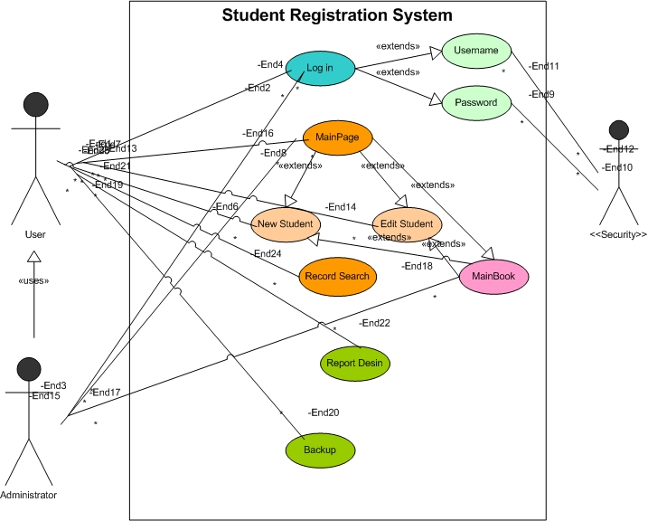**Student Registration System Use Case Diagram**

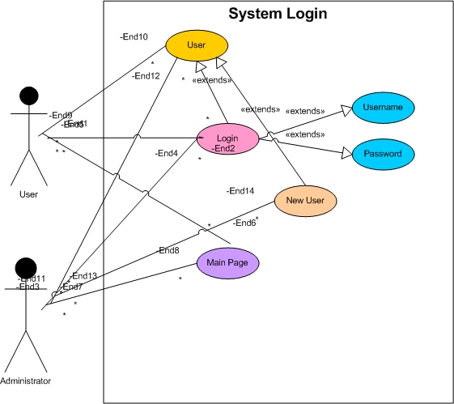**System Login Use Case Diagram**

**Scenario for Class Diagram**

This system (Student Registration System) will contain the following Classes.

(The system contain an interface, which name in StdFunction.

This interface will have two methods:

1. StdSet (); (This method will set values to all attributes)
2. StdDisp (); (This method will display us all we need)

System Classes and their related attributes are as follows:

|  |  |  |
| --- | --- | --- |
| S.No | Class Name | Attributes |
| 1 | StdInfo | * ID: long{Unique} * Name: String * FName: String * GFName: String * Age: int * SSN: long * Nationality: String * FJob: String * NLang: String * Year: Date * Image: Blob |
| 2 | StdDetails | * Gender: String |
| 3 | StdAddress | * Province: String * District: String * Village: String |
| 4 | StdRelative | * Brother: String * Uncle: String * MUncle: String * UncleSon: String * MUncleSon: String |
| 5 | StdSchoolProfile | * SchoolName: String * Class: int |
| 6 | StdLetter | * LetterNo: String{Unique} * DOA: Date |
| 7 | User (For System authentication) | * ID: int {Unique} * Name: String * Password: String * Post: String |
| 8 | Login (authenticate users) | * Name: String * Password: String |

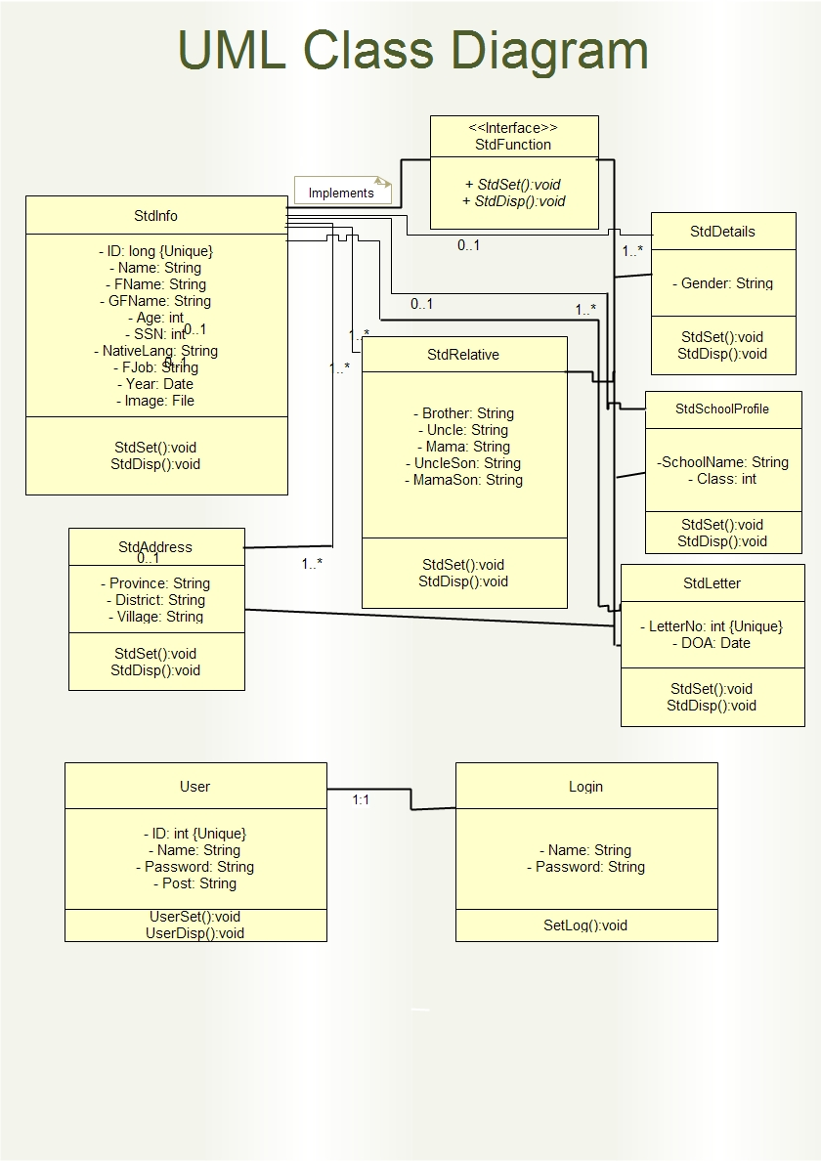**Class Diagram for Student Registration System**

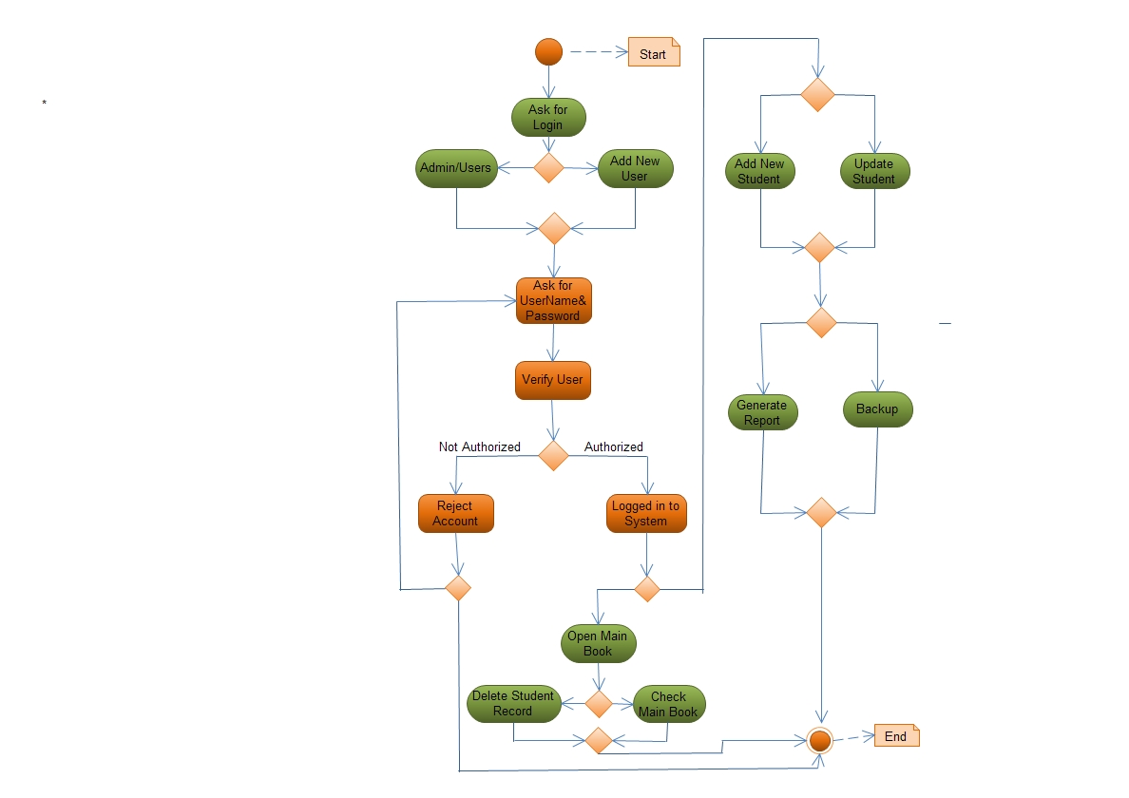**Activity Diagram for Student Registration System**